# Web 3 Practical– 960.css

* Using the 960 framework transform the provided HTML files into the following outputs:

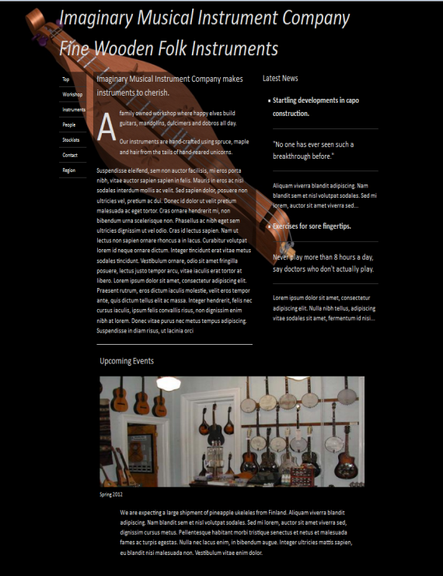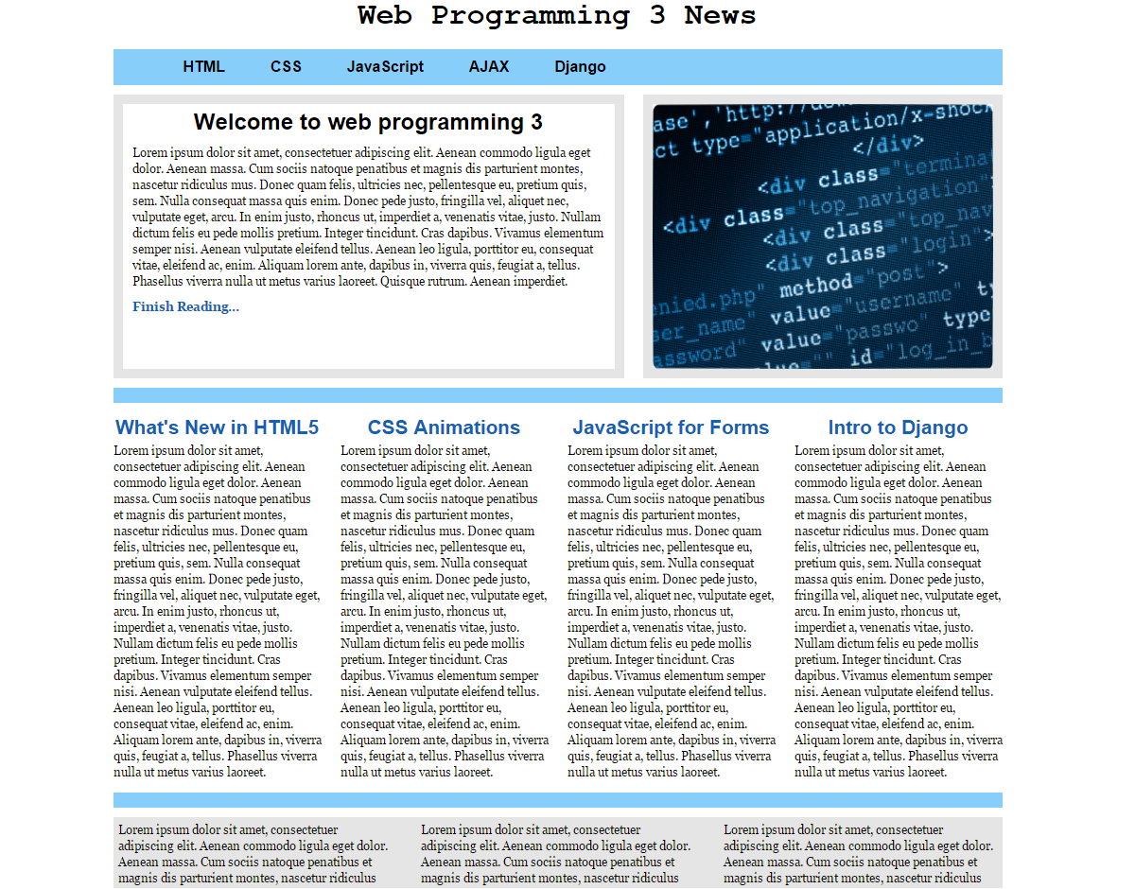

* In order for you to get exposed to different ways of doing things , I would suggest to use a local 960 CSS framework file in the 1st exercise and a content delivery network for the 2nd exercise.
* Note 2: Documentation about the 960 grid system can be found at: <http://960.gs/>